NUAST Careers Education
Parent support booklet 2022-23

Please feel free to contact our Careers email- careersadvice@nuast.org and follow the link for our Virtual Careers Library https://nuast.org.uk/page.php?p=vcl

Table of Contents
Our aim 3
Who is involved? 4
What are the Gatsby Benchmarks? 5
Overview of NUAST Futures Friday Careers programme 6
What your child can expect in Year 7 9
What your child can expect in year 8 10
What your child can expect in Year 9 11
What your child can expect in Year 10 13
What your child can expect in Year 11 15
What your child can expect in Year 12 17
What your child can expect in Year 13 19
Student Career options 21
Using Unifrog 23
Signing in with Unifrog 24
Using Kudos 25
Useful Links 28

Our aim
At NUAST we aim to make careers education something that flows through your child’s entire time at school, not just something that is bolted on at key points. Schools are now judged in their careers provision by something called the Gatsby Benchmarks, and we aim to meet or exceed all of these in what we provide for your child. We will use our links with local businesses and the University of Nottingham to offer careers opportunities, workshops and inspiring careers talks to students, so that by the time they leave us in year 11 or year 13, our students have encountered a variety of careers and employers.
We will provide a weekly tutor time session on careers, which progresses from students understanding their own selves and skills, to understanding more of the labour market, the kinds of careers out there, along with who and what can help them achieve their aims.
We will provide digital resources that students can use to plan out their careers and learn about what they would like to do. We will keep our own accurate records of students’ own ambitions so we can match students to the right opportunities.
Moreover, we will try to be open, honest and approachable so that any young person with a career aspiration can come to us for the help they need.
An overview of the key timeline for your child
What | When?
Receive careers education | Every week, every year. This is done during one tutor time session every week, plus at different points in the school’s personal development curriculum
Learn about the different careers and jobs that exist | Year 8 and year 9
Meet employers and people from different careers areas | Every year from year 8. We aim for your child to meet an employer every year.
Visit a university | They will do this in year 9 and in year 12
Choose their GCSE options | This is done in Spring term of year 9
Meet with a professional careers advisor | Three times;  In year 9 to help choose options, in year 11 to support with post 16 options and at the end of year 12 to support Post 18 options.
Go on work experience | Twice;  In year 11 and in year 12/13
Learn about Post 16 options | The Careers lead will do year group session on these options on this in October of year 11, after which one tutor time session per week will be devoted to students applying for post 16 courses
Apply for college/ sixth form/ Apprenticeships for after Y11 | This is done in the Autumn and Spring terms of year 11. By the summer term it is getting quite late to do this
SEN students discuss their options with the SENCO and careers leader | This is done in the Spring term of year 11
Have a mock job interview | Twice; in year 11 and year 13 via our careers convention
Apply for University | This must be done in Year 13, before 15th January

Who is involved?

Mr Cox
SENCO
SCox@nuast.org

Ms Bassett
NUAST Careers lead
kbassett@nuast.org

Andy Edwards
Assistant Principal and Head of careers
aedwards@nuast.org

Careers at NUAST is led by Mr Edwards, Assistant Principal for Post 16 and Careers. Mr Edwards has many years’ experience of navigating Post 16 students through UCAS and apprenticeship applications and leads the strategy for our careers education. Mr Edwards oversees the whole careers education to make sure we are giving your child what we have said we will.
Ms Bassett is our careers leader. Her role is to make sure the whole NUAST careers programme is running smoothly, to check on the quality of the sessions being provided, to ensure we keep accurate records of what each child has engaged with and to organise exciting opportunities and events.
All students are welcome to contact either Mr Edwards or Ms Bassett if they want any help or advice about their future careers.
Mr Cox is our SENCO, and together with Mr Edwards is there to support our students who have special educational needs with their next steps in education.
Please feel free to email any of these staff, or your child’s tutor, if you have any questions about careers.
We also have a dedicated Careers email address that students or parents can contact to get advice- careersadvice@nuast.org
We also have an excellent Virtual Careers Library full of links and connections to different career and college routes https://nuast.org.uk/page.php?p=vcl

What are the Gatsby Benchmarks?
In 2018 the Government launched a new careers standard, called the Gatsby Benchmarks. These are 8 things that schools are expected to provide for a good careers education, and how NUAST meets these. It is our responsibility to meet these standards for your child.
Benchmark | What is expected | How NUAST meets this
1. A stable careers programme - | Every school and college should have an embedded programme of career education and guidance that is known and understood by students, parents, teachers, governors and employers. | With a weekly tutor time careers programme, taught by your child’s tutor.
2. Learning from career and labour market information | Every student, and their parents, should have access to good quality information about future study options and labour market opportunities. They will need the support of an informed adviser to make best use of available information. | Through our online platforms, Unifrog and Kudos, as well as information available on our website careers page.
3. Addressing the needs of each student | Students have different career guidance needs at different stages. Opportunities for advice and support need to be tailored to the needs of each student. A school’s careers programme should embed equality and diversity considerations throughout. | By encouraging all students to be ambitious for themselves in everything they do. We keep records of what students want to achieve in the future and use this to offer the right opportunities to the right students.
4. Linking curriculum learning to careers | All teachers should link curriculum learning with careers. STEM subject teachers should highlight the relevance of STEM subjects for a wide range of future career paths. | Our teachers actively look for careers links in their subjects and will talk about the career relevance of different skills they teach.
5. Encounters with employers and employees | Every student should have multiple opportunities to learn from employers about work, employment and the skills that are valued in the workplace. This can be through a range of enrichment activities including visiting speakers, mentoring and enterprise schemes. | We aim to provide employer or university encounters every year that students are in school; whether this be via workshops or careers talks.
6. Experiences of workplaces | Every student should have first-hand experiences of the workplace through work visits, work shadowing and/or work experience to help their exploration of career opportunities, and expand their networks. | This will take place via trips, when they become available and through work experience.
7. Encounters with further and higher education | All students should understand the full range of learning opportunities that are available to them. This includes both academic and vocational routes and learning in schools, colleges, universities and in the workplace. | All students will have visited the local university before they leave, and all will have completed learning about different universities.
8. Personal guidance | Every student should have opportunities for guidance interviews with a career adviser, who could be internal (a member of school staff) or external, provided they are trained to an appropriate level. These should be available whenever significant study or career choices are being made. | Very student will have a 1-1 interview with a professional careers advisor in year 10/11 and year 12/13, in addition to in-house careers advice.

Overview of NUAST Futures Friday Careers programme
The careers programme is weekly, for 15 minutes on a Friday delivered by tutors

Year | Key theme | Individual themes | Rationale | Skills gained | Assessment
7 | Getting to know myself | Careers IQ | Developing students’ understanding of themselves. That they each have abilities, likes, dislikes and that these should inform their choice of career.  Introduction to Kudos | Self reflection and introspection. Self confidence | Teacher  Peer  Self
 |  | My Abilities
 |  | My interests
 |  | My values
 |  | How others see me
 |  | Promoting myself
 |  | My favourite subjects
 | The world of work | What is work? | Developing understanding of work; why we do it, what it looks like and what kind of work might be out there. This leads very well onto year 8 | Knowledge and Understanding | Teacher  Peer  Self
 |  | Why work?
 |  | Researching careers
 |  | “dicing with life”
 |  | Student career plan
8 | Futures Friday; jobs presentations | A job presentation per week, in which a 5 slide ppt is presented about an individual job each week. This tells them what the job is, what you would do day to day, what the benefits of the job are and the pay, and how you get into it; including the kinds of grades they would need to aspire to now | This is very transformational; students love these presentations and discussing them with their tutor. They are exposed to jobs they did not even know existed (things like undertaker are included as well as popular roles) they get to understand more about jobs they only know about from TV and week by week they see the comparisons. They start to see what a high and average wage for work looks like, they start to see the level of school achievement needed. | Knowledge and Understanding  Ability to compare | None- through discussion and questioning, no formal assessment
9 | Futures Friday; jobs presentations | For a term, we continue with more work presentations | Continuation to ensure good coverage | Knowledge and Understanding  Ability to compare | None- through discussion and questioning, no formal assessment
 | My school future: GCSE options | A presentation per week on subjects they can choose for GCSE, with specific discussion of career paths each subject can lead to and work characteristics that fit with it. Focus again on using KUDOS | Solid preparation for Year 9 options choices | Ability to link learning to future careers.  Future planning | None- through discussion and questioning, no formal assessment
 | Futures Friday: university of the week | Each week, tutor presents a new university or FE website and examines courses with students. Students fill in a weekly fact file document | We have spent 18 months looking at different careers; now we raise aspirations by looking at the steps students can take to get there. Students gain an understanding of local FE provision before they start their GCSEs and start to gain an understanding of the types of university courses and the grades needed | Understanding of the level they need to reach for certain careers  Self motivation | Teacher checking  Self assessment (of the opportunity)
10 | Decision making and working skills | Career Action plan | The focus now shifts to decision making skills and understanding more about the skills desired in the labour market. Students are trained in decision making behaviours in readiness for the huge decisions they need to make in year 11 | Decision making and understanding of the self, building on the work done back in year 7 and 9.  Preparation for the big decisions to come | Teacher  Peer  Self
 |  | Making decisions
 |  | Resilience
 |  | What should I do?
 |  | Predicting futures
 |  | Personal skills
 |  | Transferable skills
 | Work experience Y10 | Work experience programme |  | Experience of a relevant work place | Employer and self- work experience booklet
11 | Exploring options and taking opportunities | Career action plan | Getting students to apply early for FE and P16 providers | Exploring as many opportunities and P16 providers as possible | Tutor assessed by outcome
 |  | FE and 6th form options presentations
 |  | Applications
 |  | Careers convention
 |  | Researching options
 | Ready for careers | Goal setting | Understanding who can help you with careers development and why it is important to take opportunities and how to do so | Understanding where to get help and how to help yourself | Teacher  Peer  Self
 |  | Accessing your allies
 |  | Career pathway planning
 |  | CV writing
 |  | 1-1 interview
12 | Professional skills | A series of sessions on key professional skills relevant for the workplace and interviews, including eye contact, greetings, dress and conversational skills. Also sessions on personal branding and maintaining a professional internet presence | Developing the ability to make a positive impression on employers immediately | Professional skills for employment and future training | By outcome and discussion
 | University of the week | Weekly look at a different university of apprenticeship provider, with students completing a fact file that they keep | Students are building a knowledge bank of universities they like the look of ready for open day season in the summer and UCAS choices. | Knowledge and understanding | Self assessment (of the opportunity)
 | Y12-13 Work experience | Work experience programme |  | Experience of a relevant work place | Employer and self- work experience booklet
13 | UCAS
 | Careers convention | Y13 NUAST careers convention and employer interviews | Give students real interview experience and understanding of the current labour market | Direct, conversational experience | Self assessed
 | Life skills | Students have already decided their immediate next step; we now teach them about independent living with sessions on bank accounts, cards, loans, tenancy agreements, consumer rights, etc. Potentially some basic cooking skills as well | Students are prepared for living away from home for the first time | Practical knowledge and understanding | Informal assessment

What your child can expect in Year 7
Below is what we have offered in the past and what we aim to offer, providers permitting, each year. We get students started on their careers education right away in year 7. We understand that many students will have only a very early idea of what they might like to do for a future career and that many students will have little concept of what options there are.
Our year 7 careers education is all about teaching year 7 students about themselves and about what real work and real jobs look like. This is done through our tutor time careers programme, where students will learn about themselves and their own skills, before moving on to learning about the world of jobs and work. These are all 15 minute weekly sessions. We aim to also provide a visit to the University of Nottingham and at least one relevant employer career talk.
Year 7’s will also be introduced to Kudos, one of our online careers systems. Students answer a series of questions about themselves, their likes and dislikes and Kudos matches them up to careers that match their preferences and skills.
Year 7
What? | When | How? | Why? Gatsby benchmark
Introduction to understanding yourself , your interests and your abilities- Careers scheme of work | Autumn term | Via Tutor time scheme of work | 1. A stable careers programme  8. Personal guidance
Introduction to employers | Spring term | MMEP inspiring careers programme; students should hear from a public servant and a medical professional about their career; via assembly | 5. Encounters with employers and employees  4. Linking curriculum learning to careers
Introduction to work | Summer term | Via Tutor time scheme of work | 1. A stable careers programme  2. Learning from career and labour market information
Access to KUDOS system | All year | Kudos is our online platform, which helps students to learn more about their strengths, their skills and what they enjoy, and then matches these attributes to potential careers they might explore. The platform also provides extensive careers guidance and up to date labour market information. | 2. Learning from career and labour market information  3. Addressing the needs of each pupil  8. Personal guidance

What your child can expect in year 8
Below is what we have offered in the past and what we aim to offer, providers permitting, each year. The focus in year 8 is getting to know the jobs market. Your child will be signed up to Unifrog and Kudos, the outstanding careers platforms that we use to help students develop a CV, learn about different job roles and understand what career paths might best suit their skills and preferences. The year 8 careers curriculum focuses on “futures Friday” in which students are presented each week with a different career, in which they learn about the entry routes, the day to day job, the hours and pay and the benefits of that career. Over the year, year 8 students get a fantastic overview of a wide variety of jobs at all levels and can compare the kinds of hours, pay and grades needed to get those jobs.

What? | When | How? | Why?
Unifrog sign up | Autumn term | Via assembly | 1. A stable careers programme
Introduction to employment competencies | Autumn/ spring term | In directed study, via Unifrog scheme of work | 1. A stable careers programme  3. Addressing the needs of each pupil  2. Learning from career and labour market information
Introduction to different careers | Whole year | Students learn about different specific jobs via Unifrog, including pay and how to qualify; via careers scheme of work | 1. A stable careers programme  3. Addressing the needs of each pupil  2. Learning from career and labour market information
Careers Fair | Autumn Term- November | NUAST careers fair after school- invite to local colleges, sixth forms, training providers, universities and apprenticeship providers to have stalls and talk to students and parents year 8-13 | 3. Addressing the needs of each pupil  2. Learning from career and labour market information  5. Encounters with employers and employees  7. Encounters with further and higher education
Inspiring futures scheme | Spring term | MMEP inspiring Futures programme; students should hear from an engineer and a science professional | 5. Encounters with employers and employees  2. Learning from career and labour market information
Other activities | Whole year | Any other activities that open up over the year; eg Barclays life skills, speakers4schools | 5. Encounters with employers and employees  7. Encounters with further and higher education
Pupil Premium visit to Nottingham Trent University | Summer | Whole day trip for PP students to tour NTU and learn about careers and research planning | 7. Encounters with further and higher educatio
Access to KUDOS system | All year | Kudos is our online platform, which helps students to learn more about their strengths, their skills and what they enjoy, and then matches these attributes to potential careers they might explore. The platform also provides extensive careers guidance and up to date labour market information. | 2. Learning from career and labour market information  3. Addressing the needs of each pupil  8. Personal guidance

What your child can expect in Year 9
Below is what we have offered in the past and what we aim to offer, providers permitting, each year. In year 9, students are being prepared to make their GCSE options choices. The year 8 Futures Friday programme continues initially, before students move to learning more about the individual GCSE options they can take, before finally moving to “university of the week” where students will each week look at a university or apprenticeship provider and the courses or opportunities they offer. Students are strongly encouraged to use our Kudos system in year 9 to look at what kinds of future careers will suit them well and which GCSE options will best support them.
What? | When | How? | Why?
Creation of first careers plan | Autumn term | Via assembly and Futures Fridays | 1. A stable careers programme
Labour market and skills based activities | Whole year | Via futures fridays | 2. Learning from career and labour market information
Update of careers competencies and activities | Autumn/ spring term/ summer term | In directed study, via Unifrog scheme of work | 1. A stable careers programme  3. Addressing the needs of each pupil  2. Learning from career and labour market information
Careers Fair | Autumn Term- November | NUAST careers fair after school- invite to local colleges, sixth forms, training providers, universities and apprenticeship providers to have stalls and talk to students and parents year 8-13 | 3. Addressing the needs of each pupil  2. Learning from career and labour market information  5. Encounters with employers and employees  7. Encounters with further and higher education
Introduction to different careers | Whole year | Students learn about different specific jobs via Unifrog, including pay and how to qualify; via careers scheme of work | 1. A stable careers programme  3. Addressing the needs of each pupil  2. Learning from career and labour market information
Inspiring futures scheme | Spring term | MMEP inspiring Futures programme; students should hear from an finance professional, a computing professional and a medical professional | 5. Encounters with employers and employees  2. Learning from career and labour market information
1-1 careers interviews with ideas4careers | Spring term | 30 minute 1-1 interview with an independent careers advisor to discuss future careers linked to GCSE options | 8. Personal guidance
Year 9 options taster week | Spring term | A taster day that enables you to “test out” subjects that you might wish to take for GCSE | 1. A stable careers programme  3. Addressing the needs of each pupil  8. Personal guidance
Year 9 Options speed dating | Spring term | A day where students get to meet year 10 students studying different GCSE options and talk to them about what the qualification is like | 8. Personal guidance
Year 9 options skills week | Spring term | A week in which teachers in each subject spend time explaining the skills students need for the GCSE qualification, which students then record and match to their own preferences | 8. Personal guidance
Year 9 options session UoN | Spring term | Options workshop run by University of Nottingham | 7. Encounters with further and higher education
Year 9 options review | Summer term | Review of current options with member of pastoral/ careers team to check they are suiting you | 8. Personal guidance
Introduction to University- UoN Tour | Autumn term | Tour of UoN and university talk | 7. Encounters with further and higher education
Access to KUDOS system | All year | Kudos is our online platform, which helps students to learn more about their strengths, their skills and what they enjoy, and then matches these attributes to potential careers they might explore. The platform also provides extensive careers guidance and up to date labour market information. | 2. Learning from career and labour market information  3. Addressing the needs of each pupil  8. Personal guidance

What your child can expect in Year 10
Below is what we have offered in the past and what we aim to offer, providers permitting, each year. The focus in year 10 will be on students developing a careers plan based on their GCSE choices and what they have learned about themselves in year 9 via Kudos and their options choice planning. We aim to introduce your child to university this year, and many of the year group will meet with real employers for one to one interviews (both of these will obviously be subject to COVID-19 restrictions in 2020-21, and we will do all we can to make them still happen. A crucial aspect of this year also is work experience, which students will take part in from late June.
What? | When | How? | Why?
Creation of careers action plan | Autumn term | Via assembly and Futures Fridays | 1. A stable careers programme  3. Addressing the needs of each pupil  8. Personal guidance
Unifrog sign up | Autumn term | For year 10 students not already signed up | 1. A stable careers programme  2. Learning from career and labour market information  3. Addressing the needs of each pupil  8. Personal guidance
Update of careers competencies and activities | Autumn/ spring term/ summer term | In directed study, via Unifrog scheme of work | 1. A stable careers programme  3. Addressing the needs of each pupil  4. Linking curriculum learning to careers
Careers Fair | Autumn Term- November | NUAST careers fair after school- invite to local colleges, sixth forms, training providers, universities and apprenticeship providers to have stalls and talk to students and parents year 8-13 | 3. Addressing the needs of each pupil  2. Learning from career and labour market information  5. Encounters with employers and employees  7. Encounters with further and higher education
Introduction to university session | Spring term | Via DANCOP or University of Nottingham | 1. A stable careers programme  2. Learning from career and labour market information  7. Encounters with further and higher education
Inspiring futures scheme | Spring term | MMEP inspiring Futures programme; students should hear from a public servant, an engineering professional and a science professional | 2. Learning from career and labour market information  3. Addressing the needs of each pupil  4. Linking curriculum learning to careers  5. Encounters with employers and employees  7. Encounters with further and higher education
Apprenticeship week activities | Spring term | Via tutor time activities; sessions based on National Apprenticeship Service | 1. A stable careers programme  2. Learning from career and labour market information
Virtual work experience | Summer term | 50 targeted students have 2-3 day virtual work experience with a top company | 2. Learning from career and labour market information  3. Addressing the needs of each pupil  5. Encounters with employers and employees  6. Experiences of workplaces  8. Personal guidance
Work experience launch | Summer | 1 week work experience placements set for October of Y11 | 2. Learning from career and labour market information  3. Addressing the needs of each pupil  5. Encounters with employers and employees  6. Experiences of workplaces
Access to KUDOS system | All year | Kudos is our online platform, which helps students to learn more about their strengths, their skills and what they enjoy, and then matches these attributes to potential careers they might explore. The platform also provides extensive careers guidance and up to date labour market information. | 2. Learning from career and labour market information  3. Addressing the needs of each pupil  8. Personal guidance
Parent presentation on Post 16 options, including online video version | Parents’ evening, summer term | A presentation to parents about the Post 16 options available to their children- A Levels, T-Levels, Other colleges and sixth forms, apprenticeships, Vocational courses and work | 2. Learning from career and labour market information  3. Addressing the needs of each pupil

What your child can expect in Year 11
Below is what we have offered in the past and what we aim to offer, providers permitting, each year. In Year 11 students are focused on their next steps. Students are given training in level 3 qualifications, how college applications work, how apprenticeships work and what to look out for. Our November careers convention will be a dedicated day of learning about careers and the jobs market, run by an independent and expert careers advice company. Students (subject to COVID restrictions and changes) will be interviewed 1-1 by real employers as interview practice.
We interview students mid year to provide advice about their current applications and tutors are constantly working with the students to encourage appropriate college applications. All Year 11 students will have a 1-1 interview with a qualified external careers advisor, either in year 11 or at the end of year 10
What? | When | How? | Why?
Creation of careers action plan | Autumn term | Via assembly and Futures Fridays | 1. A stable careers programme  3. Addressing the needs of each pupil
Futures Friday careers scheme of work | Autumn/ spring | Based around understanding next steps and how to apply | 1. A stable careers programme  4. Linking curriculum learning to careers
Update of careers competencies and activities | Autumn/ spring term/ summer term | In directed study, via Unifrog scheme of work | 1. A stable careers programme  3. Addressing the needs of each pupil
NUAST sixth form presentation | Autumn/ Spring term | Via EDW | 1. A stable careers programme
Other local colleges presentations | Autumn/ Spring term | Via Nottingham college/ Bilborough college/ confetti presentations and lunchtime stands | 1. A stable careers programme
Work experience | Autumn term | October 1 week work experience placements | 2. Learning from career and labour market information  3. Addressing the needs of each pupil  5. Encounters with employers and employees  6. Experiences of workplaces
Careers Fair | Autumn Term- November | NUAST careers fair after school- invite to local colleges, sixth forms, training providers, universities and apprenticeship providers to have stalls and talk to students and parents year 8-13 | 3. Addressing the needs of each pupil  2. Learning from career and labour market information  5. Encounters with employers and employees  7. Encounters with further and higher education
Other local apprenticeship opportunities | Autumn/ Spring term | Via local apprenticeship companies where approached, international companies, armed forces | 1. A stable careers programme  2. Learning from career and labour market information
Careers Convention | Autumn term term | Drop down day run by ideas4careers, including mock interviews with up to 16 different real employers | 1. A stable careers programme  3. Addressing the needs of each pupil  2. Learning from career and labour market information  4. Linking curriculum learning to careers  5. Encounters with employers and employees  6. Experiences of workplaces  7. Encounters with further and higher education
Inspiring futures scheme | Spring term | MMEP inspiring Futures programme; students should hear from a public servant, an engineering professional and a science professional | 3. Addressing the needs of each pupil  2. Learning from career and labour market information  4. Linking curriculum learning to careers  5. Encounters with employers and employees
Ideas4careers 1-1 interviews | Autumn/spring term | Every student gets a 1-1 interview for 45 minutes with an independent careers advisor | 8. Personal guidance
Apprenticeship week activities | Spring term | Via tutor time activities; sessions based on National Apprenticeship Service | 2. Learning from career and labour market information
Access to KUDOS system | All year | Kudos is our online platform, which helps students to learn more about their strengths, their skills and what they enjoy, and then matches these attributes to potential careers they might explore. The platform also provides extensive careers guidance and up to date labour market information. | 2. Learning from career and labour market information  3. Addressing the needs of each pupil  8. Personal guidance

What your child can expect in Year 12
Below is what we have offered in the past and what we aim to offer, providers permitting, each year. In Year 12, we introduce careers afresh for all our new starters. Every student will be signed up to Unifrog and Kudos, the fantastic online careers systems we subscribe to on behalf of students. Students begin the year being taught ‘professional skills’- from the basics of performing a winning handshake and good eye contact to developing personal online branding. In the latter part of the year students follow a detailed UCAS preparation which includes input from University of Nottingham. We also run a detailed Oxbridge and Medicine preparation scheme of work as well. Throughout the year we invite employers in to advertise their career and apprenticeship opportunities.
What? | When | How? | Why?
Professional skills sessions | Autumn term | Via Barclays life skills- students complete the skills booklet and build up a portfolio | 1. A stable careers programme
Update of careers competencies and activities | Autumn/ spring term/ summer term | In directed study, via Unifrog scheme of work | 3. Addressing the needs of each pupil
Unifrog sign up | Autumn term | For year 12 students not already signed up | 8. Personal guidance
University search fair | Autumn term | Search fair for universities and apprenticeships at Edgbaston stadium | 3. Addressing the needs of each pupil  5. Encounters with employers and employees  7. Encounters with further and higher education
Ambition Nottingham scheme and summer schools | Autumn/ Spring term | Via UoN | 3. Addressing the needs of each pupil
Careers Fair | Autumn Term- November | NUAST careers fair after school- invite to local colleges, sixth forms, training providers, universities and apprenticeship providers to have stalls and talk to students and parents year 8-13 | 3. Addressing the needs of each pupil  2. Learning from career and labour market information  5. Encounters with employers and employees  7. Encounters with further and higher education
Into University introduction sessions | Autumn/ Spring term | Via Into Unoversity for specially selected students | 1. A stable careers programme  3. Addressing the needs of each pupil
Other local apprenticeship opportunities | Autumn/ Spring term | Via local apprenticeship companies, international companies, armed forces, ASK | 2. Learning from career and labour market information  5. Encounters with employers and employees
DANCOP sessions | Autumn/ Spring term | E-mentoring, medicine, university experience | 3. Addressing the needs of each pupil
HE+ Scheme | Autumn/ Spring term | Via Peterhouse, Cambridge, for Oxbridge aspirant students- masterclasses and visits | 1. A stable careers programme  3. Addressing the needs of each pupil
Company workshops | Autumn/ Spring term | Such as IDG, RICS, Red Cross, RAF | 2. Learning from career and labour market information  5. Encounters with employers and employees
Inspiring futures scheme | Spring term | MMEP inspiring Futures programme; students should hear from a public servant, an engineering professional and a science professional | 1. A stable careers programme  2. Learning from career and labour market information  4. Linking curriculum learning to careers  5. Encounters with employers and employees
Apprenticeship week activities | Spring term | Via tutor time activities; sessions based on National Apprenticeship Service | 2. Learning from career and labour market information
Medicine Preparation scheme | Spring/ summer | Via head of careers- in depth series of sessions on the medicine application process, including sessions by UoN on UKAT | 1. A stable careers programme  3. Addressing the needs of each pupil  7. Encounters with further and higher education  8. Personal guidance
Introduction to University- UoN Tour | Autumn term | Tour of UoN and university life talk, with chance to meet undergraduate students | 7. Encounters with further and higher education
Oxbridge preparation scheme | Spring/ summer | Via head of careers- in depth series of sessions on the Oxbridge application process | 1. A stable careers programme  3. Addressing the needs of each pupil  7. Encounters with further and higher education  8. Personal guidance
University preparation scheme |  | Series of sessions delivered by UoN and NTU on preparing for university and personal statements | 1. A stable careers programme  3. Addressing the needs of each pupil  7. Encounters with further and higher education
Into University ABDOUL and personal statement workshop | Summer term | Visit to University of Leeds/ Derby for a day in the life at University | 3. Addressing the needs of each pupil  8. Personal guidance
Subject links | All year | Students in variety of subjects will have labs and lectures at UoN or competitions with local companies such as Ideagen | 2. Learning from career and labour market information  4. Linking curriculum learning to careers  5. Encounters with employers and employees
Work experience | Summer | Work experience placements in July- around 20% generated by NUAST | 6. Experiences of workplaces
Access to KUDOS system | All year | Kudos is our online platform, which helps students to learn more about their strengths, their skills and what they enjoy, and then matches these attributes to potential careers they might explore. The platform also provides extensive careers guidance and up to date labour market information. | 2. Learning from career and labour market information  3. Addressing the needs of each pupil  8. Personal guidance

What your child can expect in Year 13
Below is what we have offered in the past and what we aim to offer, providers permitting, each year. Year 13 is all about preparing students for University, Apprenticeship, job or other applications and for the next stage in their lives. We give lots of support, including external support from Ideas4careers and Into University to help students with their personal statements. The University of Nottingham support with mock interviews and our students will face mock interviews with real employers at our careers convention. All year 13 students will have a 1-1 careers interview with a professional external advisor.
What? | When | How? | Why?
UCAS sessions | Autumn term | Focussed mentoring between head of careers and tutors every morning | 1. A stable careers programme  8. Personal guidance
Update of careers competencies and activities | Autumn/ spring term/ summer term | In directed study, via Unifrog scheme of work | 3. Addressing the needs of each pupil
UoN Personal statement workshops and interview practice | Autumn term | UoN provide 1-1 personal statement sessions and mock university interviews | 3. Addressing the needs of each pupil  7. Encounters with further and higher education  8. Personal guidance
Oxbridge interviews prep | Autumn term | Via University of Nottingham department heads | 3. Addressing the needs of each pupil  7. Encounters with further and higher education  8. Personal guidance
Into University Personal statement and university life sessions | Autumn/ Spring term | Via Into University for specially selected students | 3. Addressing the needs of each pupil  8. Personal guidance
Careers Fair | Autumn Term- November | NUAST careers fair after school- invite to local colleges, sixth forms, training providers, universities and apprenticeship providers to have stalls and talk to students and parents year 8-13 | 3. Addressing the needs of each pupil  2. Learning from career and labour market information  5. Encounters with employers and employees  7. Encounters with further and higher education
Other local apprenticeship opportunities | Autumn/ Spring term | Via local apprenticeship companies, international companies, armed forces, ASK | 2. Learning from career and labour market information  5. Encounters with employers and employees
DANCOP sessions | Autumn/ Spring term | E-mentoring, medicine, university experience | 3. Addressing the needs of each pupil  7. Encounters with further and higher education
Medicine MMI mock interviews | Autumn/ Spring term | Mock interviews copying the MMI model, conducted by NUAST tutors | 3. Addressing the needs of each pupil  8. Personal guidance
Company workshops | Autumn/ Spring term | Such as IDG, RICS, Red Cross, RAF | 2. Learning from career and labour market information  5. Encounters with employers and employees
Careers Convention | Autumn term term | Drop down day run by ideas4careers, including mock interviews with up to 16 different real employers | 2. Learning from career and labour market information  4. Linking curriculum learning to careers  5. Encounters with employers and employees  8. Personal guidance
Inspiring futures scheme | Autumn/ Spring term | MMEP inspiring Futures programme; students should hear from a public servant, an engineering professional and a science professional | 5. Encounters with employers and employees
Apprenticeship week activities | Spring term | Via tutor time activities; sessions based on National Apprenticeship Service | 1. A stable careers programme
Access to KUDOS system | All year | Kudos is our online platform, which helps students to learn more about their strengths, their skills and what they enjoy, and then matches these attributes to potential careers they might explore. The platform also provides extensive careers guidance and up to date labour market information. | 2. Learning from career and labour market information  3. Addressing the needs of each pupil  8. Personal guidance

Student Career options
The three big decisions
Students at NUAST will have to make three big decisions in their time at school. This section will take you through those decisions. Firstly, a guide to “levels of study”
Level 1- Half GCSE
Level 2- GCSE or equivalent
Level 3- A Level or Equivalent
Level 4- HND (Higher National Diploma), HNC (Higher National Certificate) or foundation degree level
Level 6- degree level
Level 7- Masters level.
Year 9- Choosing GCSE options (level 2 study)
Mid way through year 9, students will be invited to choose their GCSE options subjects. English, Maths and science are compulsory, but the remaining GCSEs your child will study have an element of choice. You and your child will be given more information about the GCSEs available well prior to making this decision. This choice will have an impact; choosing subjects that are well suited to and enjoyable to your child will hopefully give a better chance of success at GCSE. The subjects your child chooses may also shape the kinds of courses they might do at sixth form or college. For instance, if your child might wish to pursue Computer Science at A level, it would be important to take this subject at GCSE.
Year 11- choosing Post 16 options (level 3 study)
This is one of the most important decisions your child will make. In year 11 they need to decide where and what they are going to study from age 16-18. It is compulsory for your child to be in some form of education until they are 18. The options include:
Sixth form (NUAST or elsewhere)- school sixth forms are smaller Post 16 centres attached to a secondary school, often with smaller numbers of students (although some, like NUAST can be quite large). Sixth forms will usually offer A levels, Btecs or some other level 3 vocational courses. These schools will have minimum GCSE grade requirements for courses, so check those out.
Colleges- these are bigger, dedicated centres designed primarily for Post 16 students (although some do some GCSEs as well). They will offer a wide range of A level and vocational courses in all sorts of subjects. If you are interested in specific career paths, you will often find a college course that will help you pursue that path. Colleges will also have minimum GCSE grade requirements for courses, so check those out.
The main colleges in Nottingham are: Nottingham College, Bilborough College, West Notts College and Confetti (which specialises in film, TV, Music, media and computing).
Apprenticeships
Apprenticeships are effectively jobs, in which a company trains (and pays) you up to work for them, while you spend around 20% of your time in college working towards a relevant qualification. At the end of your set apprenticeship you either leave the company with your qualification or they may (hopefully) choose to employ you permanently.
You could get a level 2 or 3 apprenticeship at the end of your GCSEs (level 3 is obviously better). These can be searched for in a couple of ways- please see later in the booklet. The application process differs with every apprenticeship because they are all set by the employer. Common process is:
- Apply online and potentially complete a short personal statement.
- Bigger companies may ask students to complete some online tests
- Students may have a phone interview first
- If successful, students may be invited to an “applicant day”- an all day interview in which students may do a presentation, a group task and an individual interview.
Year 13- choosing your future path
In year 13 you will choose what you want to do at a higher level. At this point you can leave education and go into work if you wish. Most students do go on to either further study or an apprenticeship.
University
From NUAST sixth form, around 80-85% of our students choose to go on to University- primarily in STEM courses. From the summer of year 12, universities will start doing Open days for students to look around and find out about courses.
Application to university is done via UCAS; students must complete a long form and a 4000 character personal statement. They must also have a teacher reference of the same length. This does take some time and so students should be starting this towards the end of year 12. The cost of a UCAS application is £25, and it can only be sent off by the head of sixth form. There are two deadlines for UCAS; 15th October for Medicine, Veterinary or Oxbridge applications, and 15th January for all other applications.
Apprenticeships
Apprenticeships are effectively jobs, in which a company trains (and pays) you up to work for them, while you spend around 20% of your time in college working towards a relevant qualification. At the end of your set apprenticeship you either leave the company with your qualification or they may (hopefully) choose to employ you permanently.
You could get a level 2 or 3 apprenticeship at the end of your GCSEs (level 3 is obviously better). These can be searched for in a couple of ways- please see later in the booklet. The application process differs with every apprenticeship because they are all set by the employer. Common process is:
• Apply online and potentially complete a short personal statement.
• Bigger companies may ask students to complete some online tests, including Psychometric tests and maths tests
• Students may have a phone interview first
• If successful, students may be invited to an “applicant day”- an all day interview in which students may do a presentation, a group task and an individual interview.

Using Unifrog

Unifrog is our incredibly powerful careers programme designed to provide a one-stop-shop where students can easily explore their interests, then find and successfully apply for their next best step after school. Unifrog helps students to explore their key interests and what career paths they can take to reach their goals.
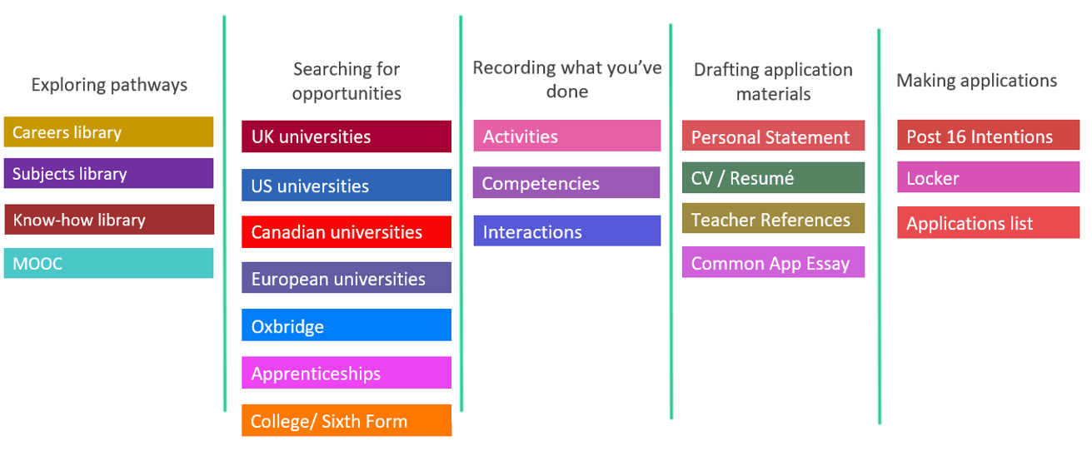
Unifrog consists of a huge number of “tools” that students can use to explore careers, make CVs and cover letters or use to record important experiences that they can use in applications.

Our UCAS university applications make heavy use of Unifrog; students can search out university places and apprenticeships according to very precise criteria and create shortlists of applications. Students use Unifrog to write their personal statements and share it with tutors, while staff use it to write student’s references.
In Year 11, students can use Unifrog to search for Post 16 college places and apprenticeships, write CVs for applications and write cover letters.
All year groups can use the tools in the Exploring pathways section to research the career pathways and subject fields that lie beyond school or college, and understand how to access them. Unifrog has an extensive careers library that includes details of hundreds of different kinds of careers, videos of people in those careers talking about them, and details of how to apply for them. This is an incredibly powerful tool, and we would highly recommend you spending some time on this with your child exploring all the exciting opportunities out there.

Signing in with Unifrog

When students first visit www.unifrog.org they will see this screen above. Students should click “sign in for first time”.
Your child will have had an email to their school account from Unifrog when their account is ready. They should follow the link in that email within 30 days of receiving it in order to register for their account. This account will then be permanent and they can access all features. Do not worry if have not met the 30 day deadline- your child should inform their tutor and we can get them re-activated. If they cannot remember their password, they should use the “forgot my password” function. The re-set will be sent to their school email address.

Using Kudos

Kudos is our new online careers platform, which can be used alongside Unifrog.
Kudos will give your child all the information they need to make important decisions about future careers and what subjects, courses and training they can do to reach their career destination.
If your child is unsure of what careers they might be interested in, Kudos can give ideas based on what they like and dislike. They can also discover what careers their subjects can lead to.
Once registered, Kudos will ask your child a series of questions about themselves, their skills, their likes and dislikes. From this, Kudos will create a list of jobs and careers that closely match your child’s skills and interests. You and your child can find out lots of information about these jobs, the grades needed for them and how to apply for them in the future.
Kudos also allows you to explore career pathways; so if your child is interested in a career in medicine, Kudos will show you hundreds of different roles in medicine that they could do. Likewise, your child may be interested in engineering, but not be sure what specifically they would enjoy; Kudos lets you explore the many different types of engineer that your child could be, and will match them to specific types that will match their survey results. Kudos will also tell you about the availability of these kinds of jobs in your local area and can even point you to the correct college or university courses to prepare for them.

Getting logged on
Your child can start by going to: https://www.cascaid.co.uk/
They should click log in (top right corner) and choose Kudos
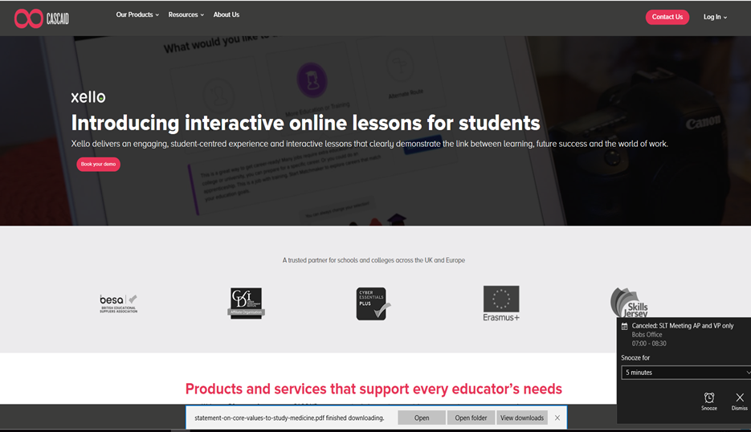

This will then take you to the Kudos login page
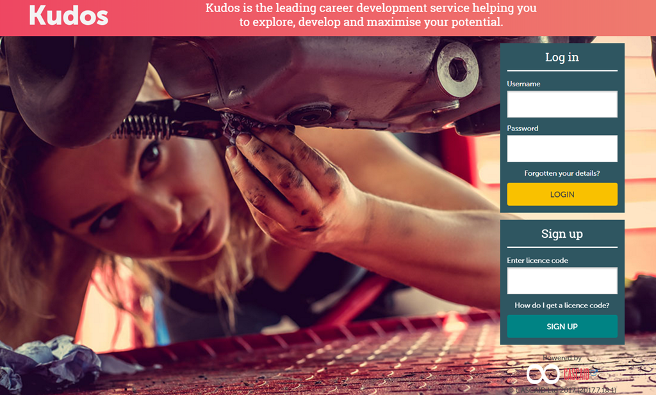

Your child’s username will be their email address.
Their password is set as Password (with a capital P) and it will then prompt your child to change this.
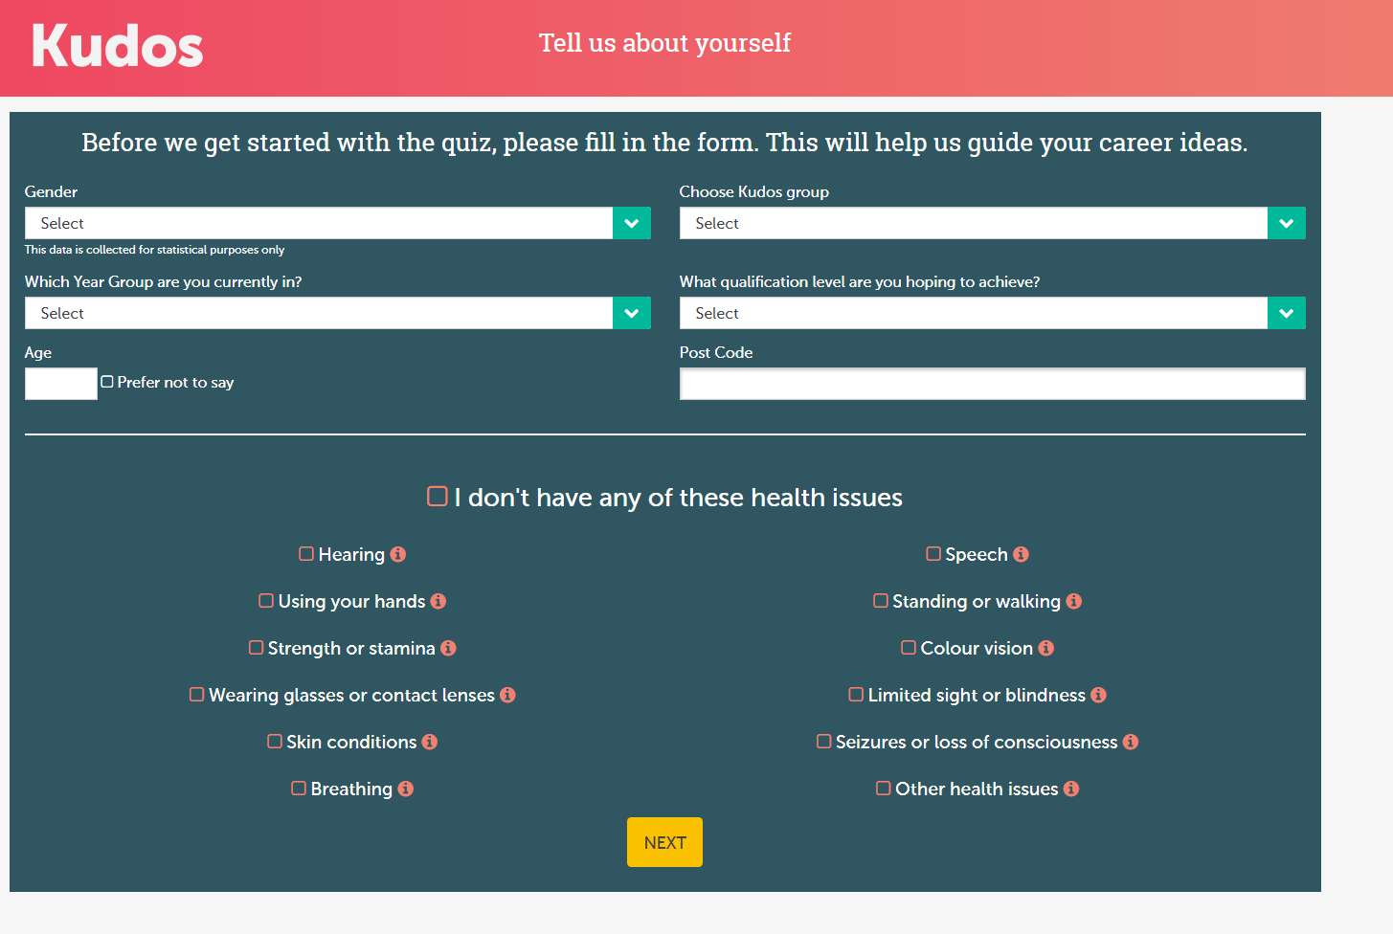
Your child will then be asked to create an account with this screen:

Where it says “what qualification level do you hope to achieve, they should select “degree level”. It does not matter if this is true or not; it just stops it from filtering out degree level jobs they might be interested in

Now your child is set up, they will see their home screen, which looks like this:
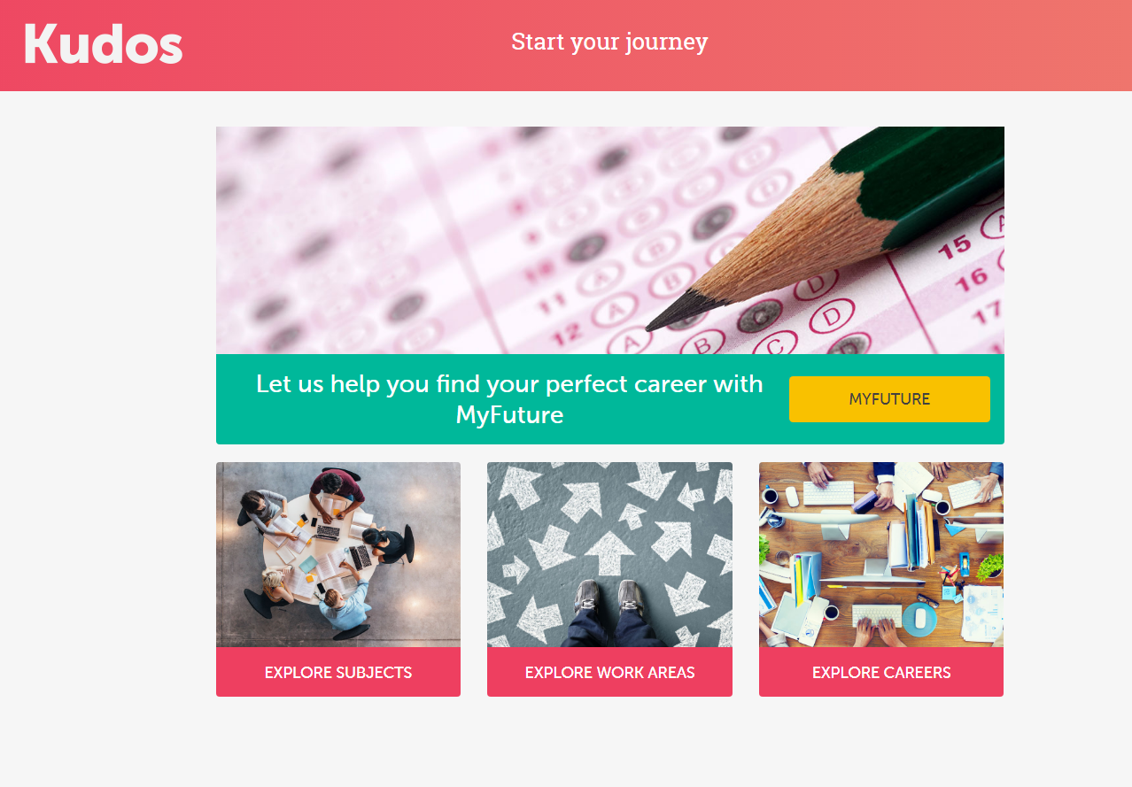

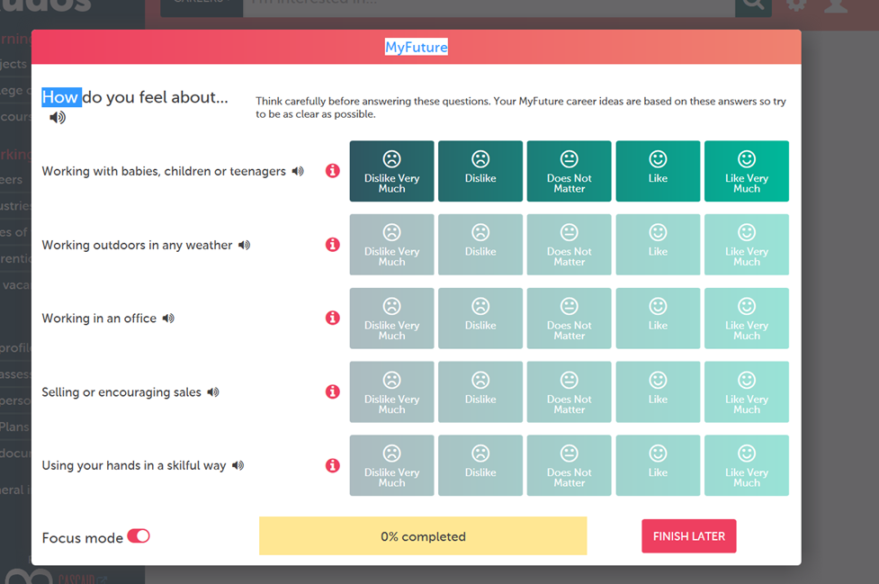
And now the fun part begins; they can use the “My Future” section to answer their first set of questions about their likes and dislikes.

There are 60 in the first section and these focus on likes and dislikes. There are another 60 in the My Skills section, and it is highly recommended that students complete these too to get the most accurate job suggestions

Useful Links

Unifrog home page- www.unifrog.org
Kudos launch page- https://www.cascaid.co.uk/
NUAST careers page- https://nuast.org.uk/page.php?p=careers
UCAS- University Application Service- https://www.ucas.com/
Parental Guidance on careers from the career writers association- https://www.parentalguidance.org.uk/
Advice for parents from Career Alchemy- https://www.careeralchemy.co.uk/inspired-teenager.html

Amazing Apprenticeships website- https://amazingapprenticeships.com/
Government Apprenticeship search hub- https://www.gov.uk/apply-apprenticeship
Getmyfirstjob.co.uk- excellent job and apprenticeship search site- https://www.getmyfirstjob.co.uk/

