**Extended Project Qualification OCR (Specification H857)**

**Course Summary**

|  |
| --- |
| **This AS level equivalent qualification is highly valuable:**   * Future employers will see that you can work independently and use skills like planning and managing a long-term project effectively. * Universities will see that you have the skills to manage your own learning effectively. * You can deepen your understanding in an area that really interests you. * It can give the competitive edge with university and employer applications. |

**WHAT IS THE OCR EXTENDED PROJECT QUALIFICATION?**



* The equivalent of half an A Level, but with an A* also achievable.
* Aims to develop you beyond your existing study programme by giving you the freedom to complete a project on an area of personal interest or benefit, while developing project management skills along the way.

**WHAT DO YOU HAVE TO DO?**

Choose, plan and manage a project. An outcome could be:

* a dissertation/investigation/report
* an artefact or design
* an event
* a performance of some kind

Alongside these outcomes, you need to keep **a documented record of the project management process**.

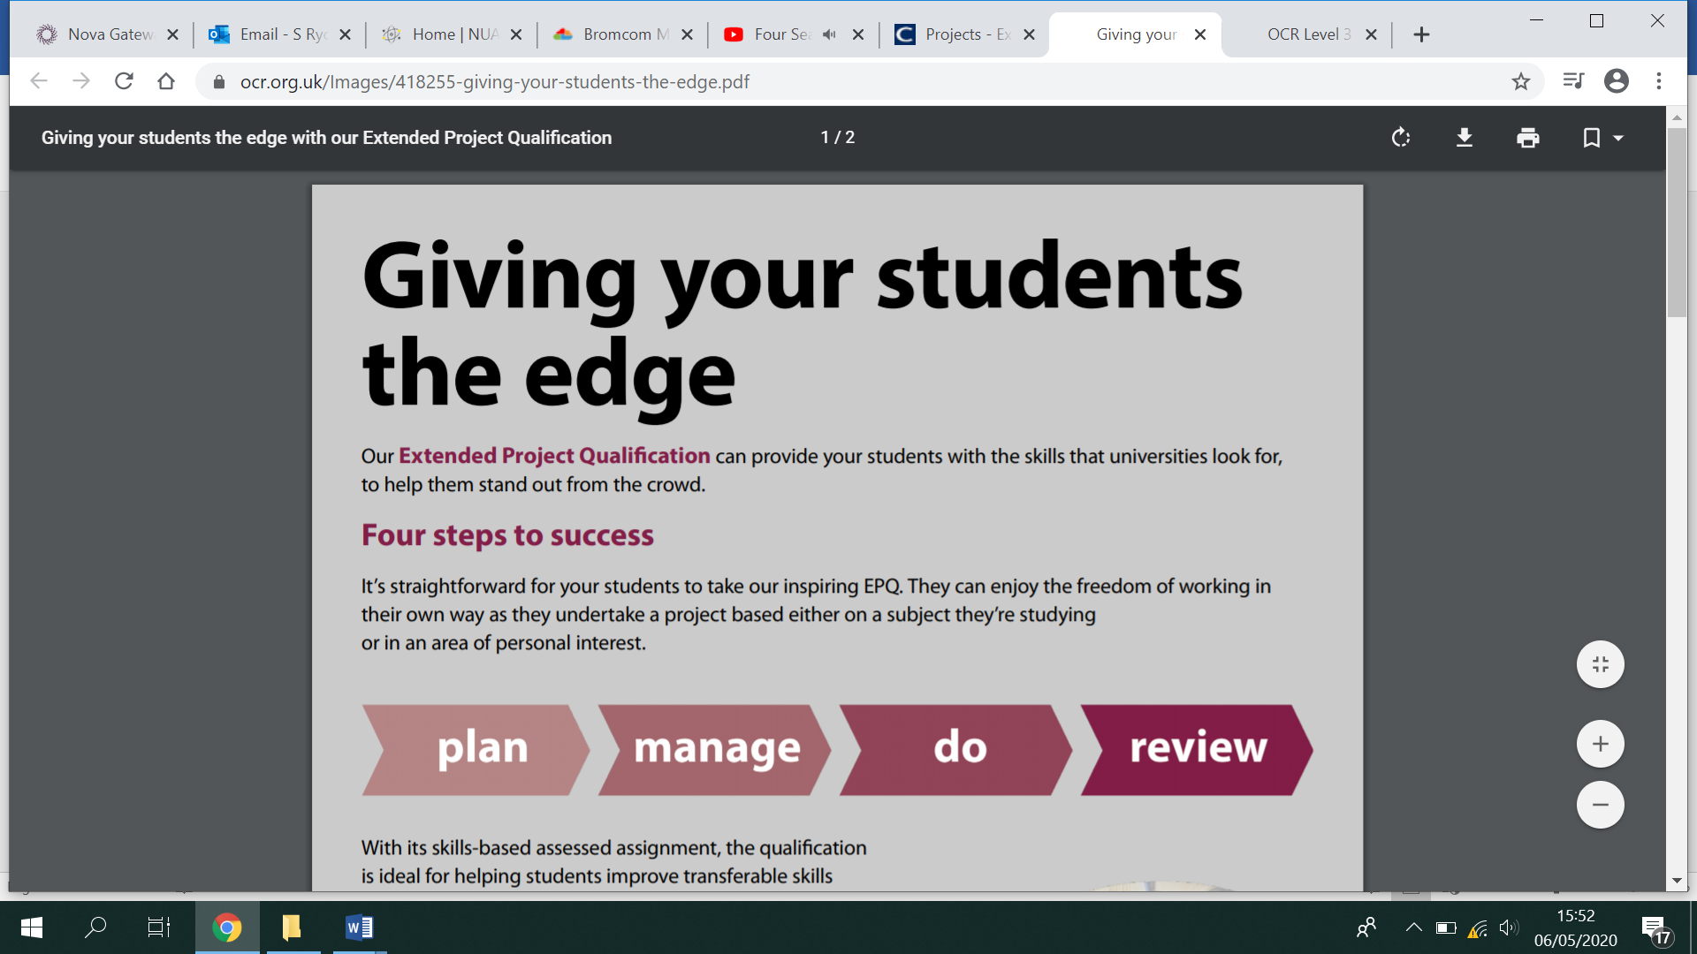

**HOW IS THE EPQ ASSESSED?**

You are assessed on your ability to manage your project:

**AO1 Manage**: Identify, design, plan and carry out a project, applying a range of skills, strategies and methods to achieve objectives. (12 marks max)

**AO2 Use resources**: Research, critically select, organise and use information, and select and use a range of resources. Analyse data, apply relevantly and demonstrate understanding of any links, connections and complexities within the topic. (12 marks max)

**AO3 Develop and realise**: Select and use a range of skills, including, where appropriate, new technologies and problem solving, to take decisions critically and achieve planned outcomes. (24 marks max)

**AO4 Review**: Evaluate all aspects of the Extended Project, including outcomes in relation to stated objectives and own learning and performance. Select and use a range of communication skills and media to present evidenced project outcomes and conclusions in an appropriate format. (12 marks max)

You are given a total mark out of 60, based on the evidence you provide to show that you have met the above criteria. It will then be sent to OCR for external moderation.

You can gain a maximum of 28 UCAS points.

**WHAT GUIDANCE CAN YOU EXPECT?**

You will complete the project in an academic year. To guide you, you will receive a mixture of taught sessions and one-to-one supervision. You are expected to spend 90 hours working independently.

**WHAT DO I NEED TO DO BEFORE SEPTEMBER?**

If you are thinking about choosing to study for an EPQ this would be as a fourth subject in addition to 3 A levels.

Over the summer you should consider potential areas of investigation or research that could be studied. Some of the best EPQs are about trying to answer a key question, e.g. Is there bias in the International Olympic Committee’s decision making when introducing and removing sports?